Merge :

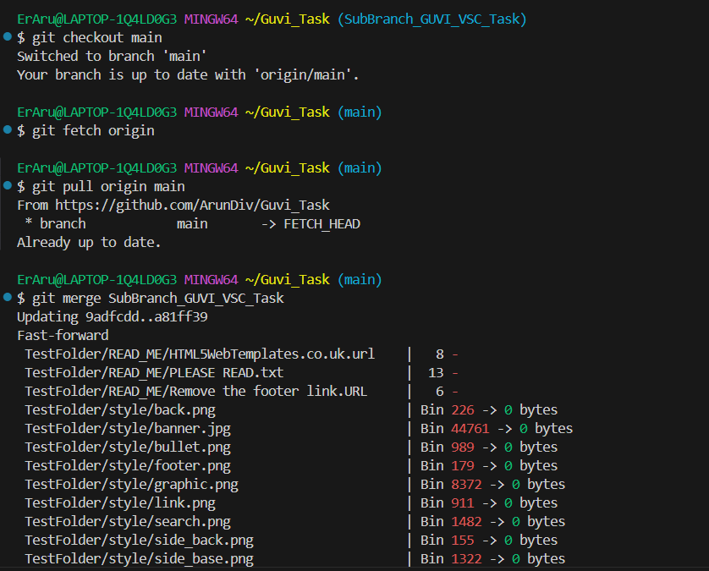

Rebase :

Stash :

